

**ISM 6217 – Database Management Systems**

**Fall 2017**

**Class Assignment 3**

**5 points**

**Task: Database Creation (JustLee – Book Sellers Database) and execute queries using Oracle SQL +**

1. **Once database has been created type and execute the following SQL statements.**
2. **SELECT table_name**

**FROM user_tables;**

**Paste results screen shot:**

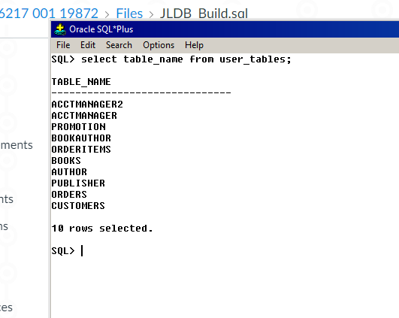

1. **SELECT \***

**FROM customers;**

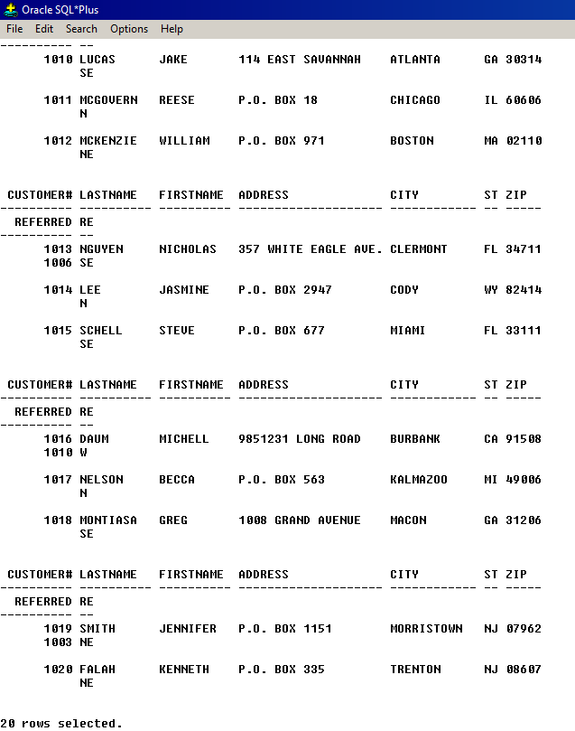

**How many data rows are there in this table ?**

**ANSWER: 20**

**Verify the data matches to the one in Appendix A, Page 540.**

**DONE**

1. **Write and execute the SQL to select only the ‘title’ column from the ‘Books’ table.**

**Paste SQL and results screen shot:**

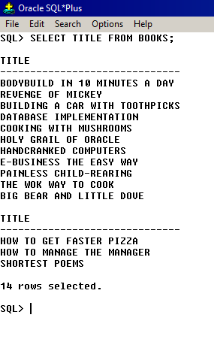

1. **Write and execute the SQL to retrieve only unique/distinct values of ‘state’ from ‘customers’ table**

**Paste SQL and results screen shot:**

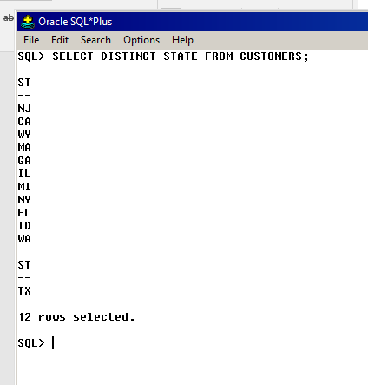

1. **Write and execute the SQL to retrieve rows with combined first and last names of the customer from ‘customers’ table. Remember there should be a space separating first with last name in the combined name**

**Paste SQL and results screen shot:**

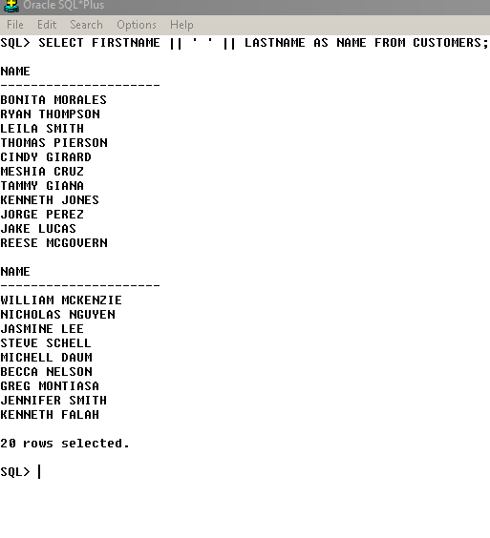

1. **Write and execute the SQL to retrieve the names of all the books under a changed heading in the query results. Hint: Use alias method**

**Paste SQL and results screen shot:**

**OLD NAME: TITLE**

**CHANGED HEADING NAME: BOOK NAME**

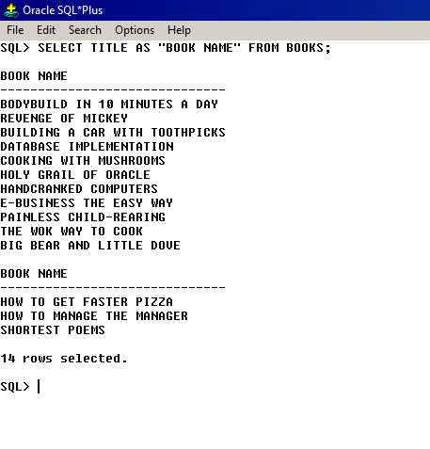

1. **Write and execute SQL to list all information for each order item. Include an item total (can be calculated by multiplying Quantity and Paideach columns. Use a column alias for the calculated value to show the heading “Item Total” in the output.**

**Paste SQL and results screen shot:**

